CREDIT CARD FRAUD DETECTION USING ML
- The main objective of this project is to build a ml model that can identify fraudulent & genuine transactions.
DataSet Description :
- The dataset contains details like Time, V1 to V28, Class, Amount.
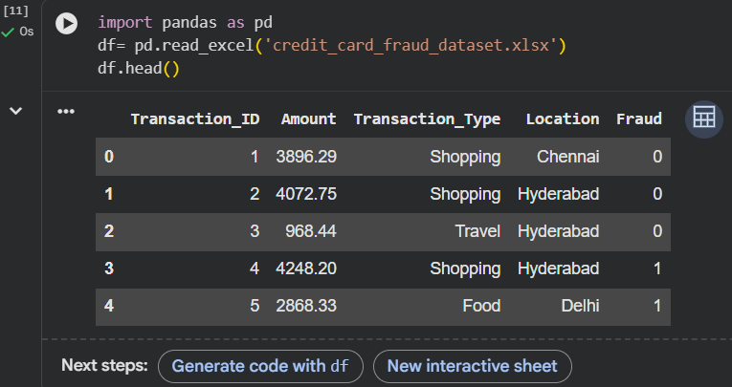
Tools & Technologies Used :
- Python
- Google Colab
- Pandas
- Scikit-learn
Data Preprocessing:
- Missing values were checked & dataset was analysed using pandas functions.
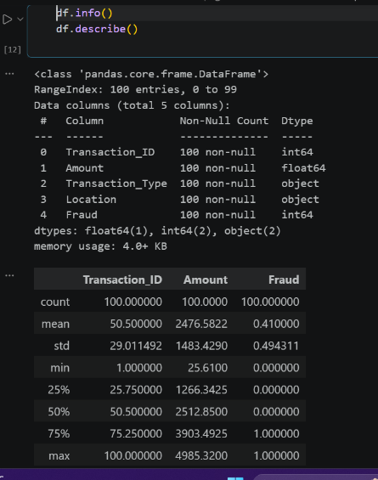

This is code file
Data Visualization : Heatmap used to analyse relationships between variables
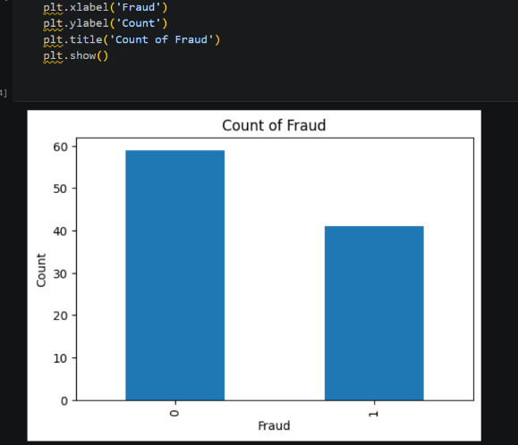
Model Building : Logistic Regression algorithm was used for creditcard fraud detection.
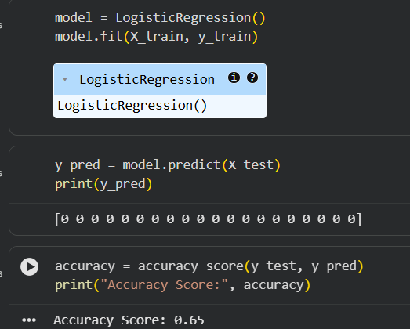
Prediction & Result :

Classification Report :
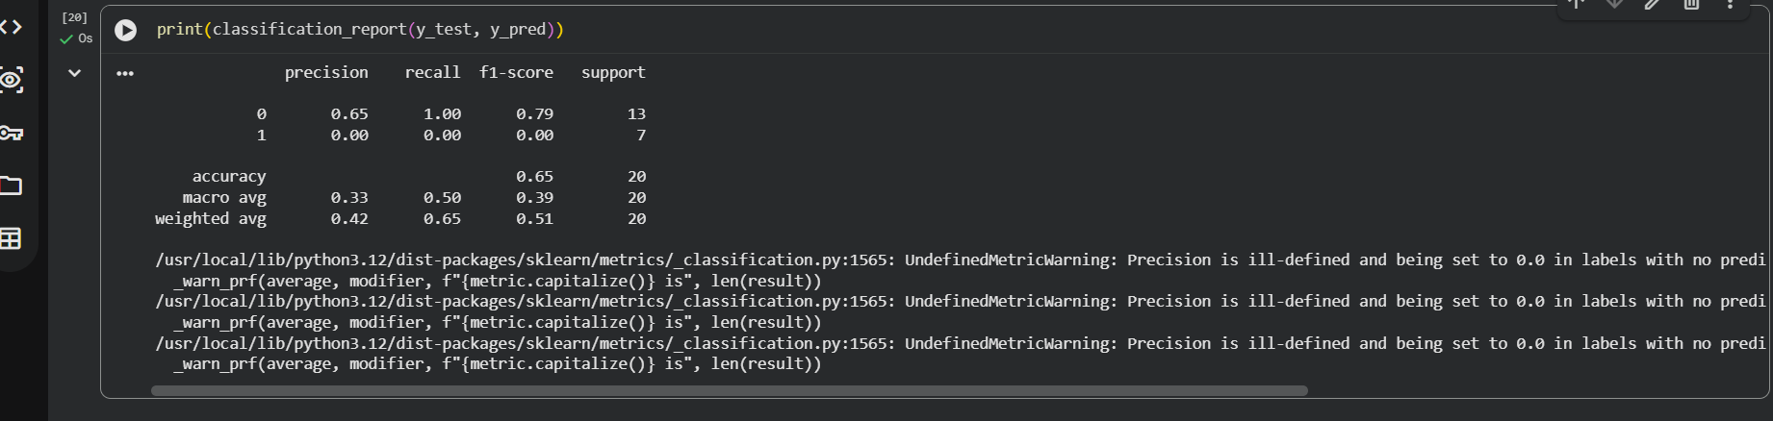
Conclusion :
- This project demonstrates how ml can be used for fraud detection in financial transactions
- The model helps in identifying fraudulent activities efficiently.

